Rajshahi University of Engineering & Technology
Department of Computer Science of Engineering

Experiment No: 02
Name of Experiment: Arrays, Records and Pointers

Submitted by:

Name: Md. Ariful Islam
Roll No.: 1803046
Group: 2nd Thirty
Date of Exp.: 08-09-2019
Date of sub. : 16-09-2019
Series: 18 Series

Submitted to:

Rizoan Toufiq
Assistant Professor
Department of Computer Science & Engineering
Rajshahi University of Engineering & Technology

Machine configuration:
ASUS X510UF
CORE I5 8th Gen Processor
Up To 3.4 GHz
8 GB RAM
OS WIN 10

INDEX

Preblem No. | Name of Problem
01. | Traversing Linear Array
02. | Inserting into a Linear Array
03. | Deleting from a Linear Array
04. | Update the value of Kth value of a Linear Array
05. | <empty>
06. | <empty>
07. | <empty>
08 | <empty>
09 | <empty>
10. | <empty>

Theory: Data structures are classified as either Linear or Nonlinear. A data structure is said to be linear if its elements are from a sequence or from a linear list. There are two basic ways to represrnting a linear structure in memory:
- Array.
- Linked list.

The operations one normally performs on any linear structure are include the following :
- Traversal
- Search
- Inserting
- Deletion
- Sorting
- Merging Etc.

This Lab is just about Array. In next Labs we will work with Linked lists.

A Linear Array is a list of finite number n of Homogeneous data elements (i.e., data elements of the same type) such that:

1. The elements of the array are referenced respectively by an Index set consisting of n consecutive numbers.

2. The elements of the Array are stored respectively in successive memory locations.

The number n of elements is called the Length or Size of the Array.

Problem 1: Traversing Linear Array.

Flow Chart:

START

K: LB

K K+1
< = >
K : UB

END
LA[K]
Algorithm:
(Given a linear array LA with Lower bound LB and upper bound UB. This algorithm traverses LA)
1. Set K := LB
2. Repeat 3 and 4 while K≤UB
3. Write: LA[K].
4. Set K:=K+1.
[End of step 2 loop]
5. Exit

Code:

#include<stdio.h>

int main()

{

int K,LB,UB,LA[10]={23,56,34,58,98,86,75,71,91,47};

scanf("%d %d",&LB,&UB);

K=LB-1;

while(K<UB)

{

printf("%d ",LA[K]);

K=K+1;

}

return 0;

}

Output:

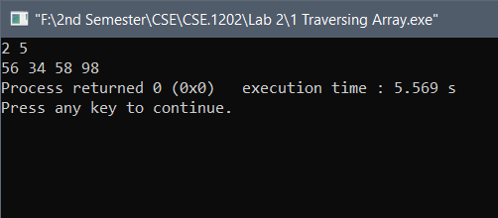
Problem 2: Inserting into A Linear Array.

Flow Chart:

START

READ LA,N,K,X

J: N

J: J-1
< = >
K : J

LA[J+1]: LA[J]
LA[K]: X

N: N+1

END

Algorithm:
INSERT (LA, N, K, X)
(Here LA is a linear array with N elements and K is a positive integer such that K≤N. This algorithm inserts an element x into the Kth position in LA)
1. Set J:=N.
2. Repeat steps 3 and 4 while K≤J
3. Set LA[J+1] := LA[J]
4. J:=J-1.
[End of step 2 loop]
5. Set LA[K]:=X.
6. Set N:=N+1.
7. Exit

Code:
#include<stdio.h>

int main()
{
int J,K,X,LA[100]={23,54,67,89,88,76,57,32,12,69},N=10;

scanf("%d %d",&K,&X);

K=K-1;
J=N-1;
while(K<=J)
{
LA[J+1]=LA[J];
J=J-1;
}

LA[K]=X;
N=N+1;
for(J=0;J<N;J++)
printf("%d ",LA[J]);

return 0;

}

Output:

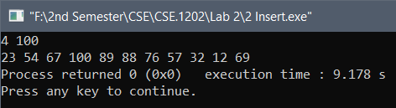

Problem 3: Deleting from A Linear Array.

Flow Chart:

START

READ LA,N,K,X

X: LA[K]

J: K

J: J+1
< >=
J : N

LA[J]: LA[J+1]
N: N-1

END

Algorithm:
INSERT (LA, N, K, x) (Here LA is a linear array with N elements and K is a positive integer such that K≤N. This algorithm deletes the Kth element from LA)
1. Set x:=LA[K] and J :=K.
2. Repeat steps 3 and 4 while K<N
3. Set LA[J] := LA[J+1]
4. J:=J+1.
[End of step 2 loop]
5. Set N:=N-1.
6. Exit

Code:
#include<stdio.h>

int main()
{
int J,K,X,LA[100]={23,54,67,89,88,76,57,32,12,69},N=10;

scanf("%d",&K);

X=LA[K-1];
J=K-1;
while(J<N-1)
{
LA[J]=LA[J+1];
J=J+1;
}

N=N-1;
for(J=0;J<N;J++)
printf("%d ",LA[J]);

return 0;

}

Output:
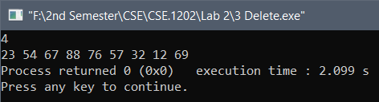
Problem 4: Update the value of Kth value of A Linear Array.

Flow Chart:

START

READ LA,N,K,X

J:N
J 1

J++

<=
END

!= ==
J : K

A LA[J]

LA[J]: X

BREAK

Algorithm:
INSERT (LA, N, K, X) (Here LA is a linear array with N elements and K is a positive integer such that K≤N. This algorithm updates the Kth element of LA)
1. Repeat for J = 1 to N by 1
2. If J = K then:
A = LA[J].
LA[J] = X.
[End of step 1 loop].
3. Exit

Code:

#include<stdio.h>

int main()
{
int A,X,I,K;
int LA[10]={34,67,87,54,26,84,59,73,89,97},N=10;

scanf("%d %d",&K,&X);
for(I=0;I<N;I++)
{
if(I==(K-1))
{
A=LA[I];
LA[I]=X;
}
}
for(I=0;I<N;I++)
printf("%d ",LA[I]);

return 0;

}

Discussion: The problems were based on Array. After trying sometime I had solved the problems.

The End

